# School_District_Analysis

Deliverable 3: A Written Report for the School District Analysis (25 points)

##Overview of the school district analysis

The goal of this analysis is to determine the impact of academic dishonesty of the 9th graders at Thomas High School on the results of the City's standardized testing results and subsequent funding analysis.

##How is the district summary affected?

As noted in the summaries below, the overall district performance is only modified slightly as a result of nullifying the fraudulent grades, with the average math scores dropping one tenth of a percent and the average reading score staying just about the same. The overall passing percentage also only drops by one tenth of a percentage point.

Before:

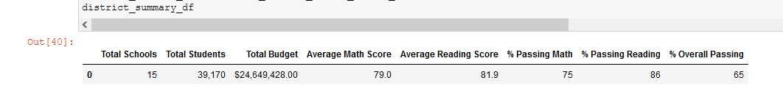

After:

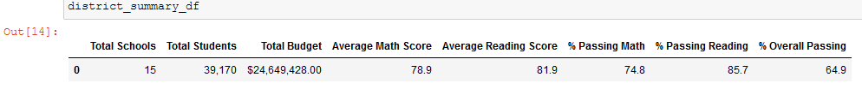

##How is the school summary affected?

Drilling down into the specifics of the summary of schools and noting that the error in grades does not impact the overall number of students, the budget remains unchanged across the board, and the Thomas High scores shift downwards as a result of changes made to the 9th grade student grades. Average math scores drop by .06 and average reading scores by .05, leading to an overall passing percentage drop of .31

Before:

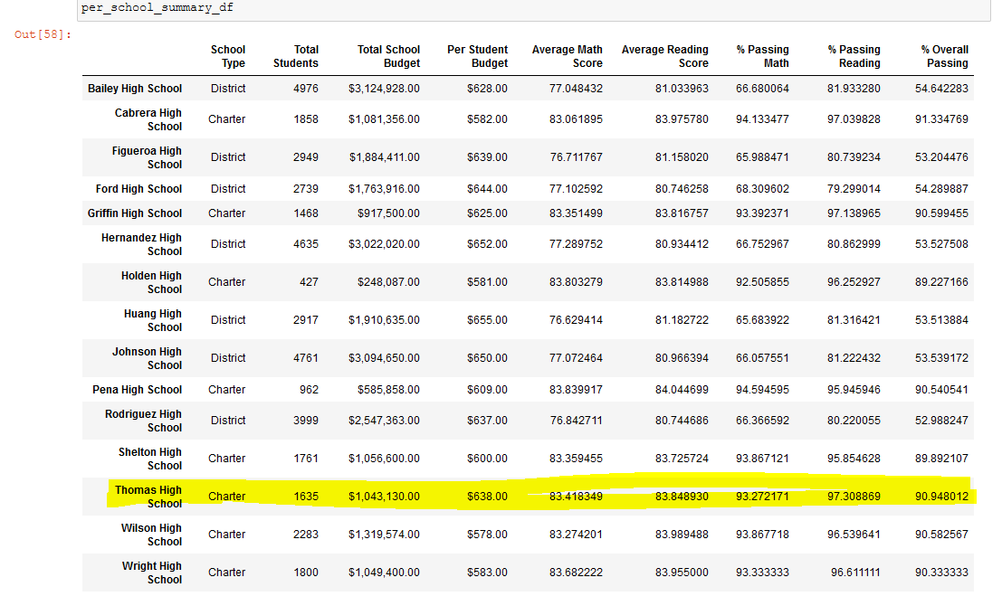

After: 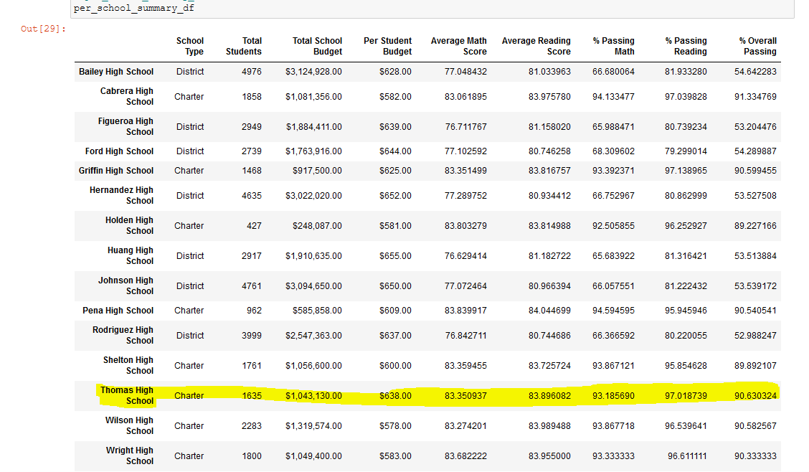

##How does replacing the ninth graders’ math and reading scores affect Thomas High School’s performance relative to the other schools?

Interestingly, the change of grades had negligible impact on the overall performance of the students in relation to the other schools. While the overall passing percentage for the school dropped by .31%, this change was not enough for the school to move in it’s overall rankings compared to the other schools, and it maintains it’s place as the second highest school in the district.

Before:

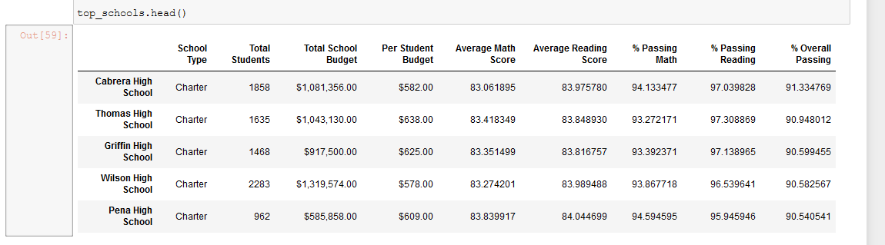

After:

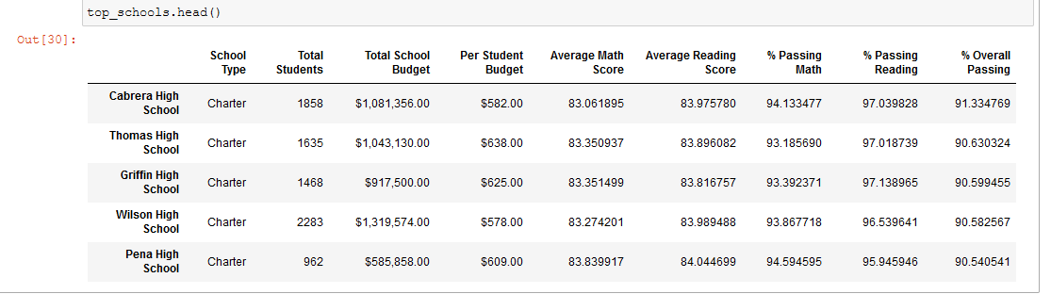

##How does replacing the ninth-grade scores affect the following:

##Math and reading scores by grade

The math and reading scores by grade remain largely unaffected by the changes made, except in that the 9th grade totals for Thomas High School are no longer available.

##Scores by school spending

As noted in the spending summary statistics, the spending ranges per students also remain unaffected by the score changes.

Before:

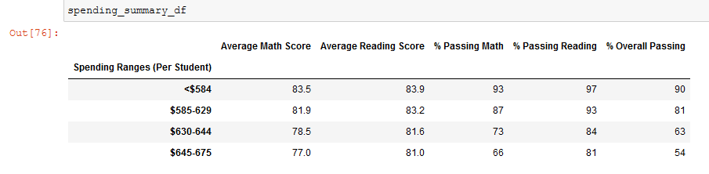

After:

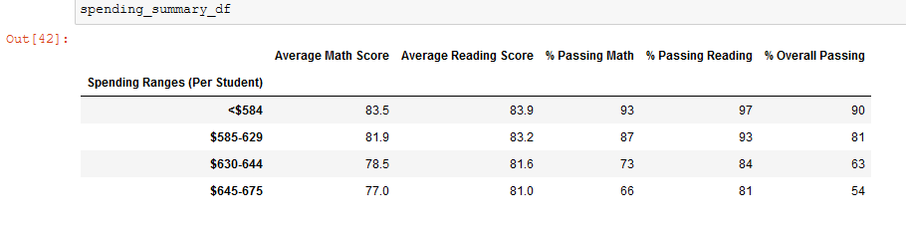

##Scores by school size

Likewise, by school sizes, the impact has no noticeable change.

Before:

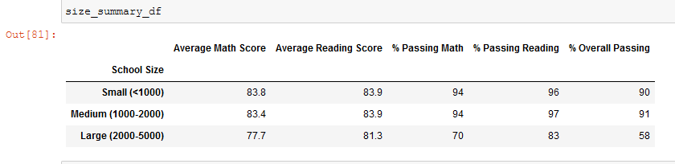

After:

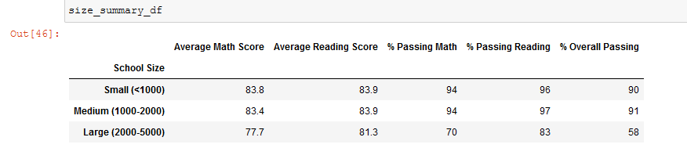

##Scores by school type

And finally, by school sizes, the impact has no noticeable change.

Before:

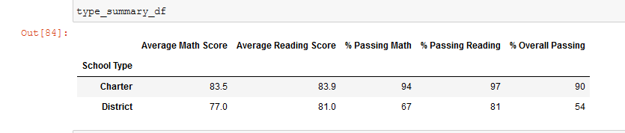

After:

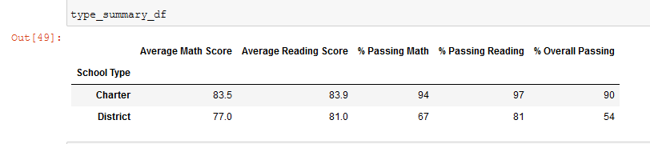

##Summary: Summarize four changes in the updated school district analysis after reading and math scores for the ninth grade at Thomas High School have been replaced with NaNs.

The primary impacts are the specific performance levels for the Thomas high school district itself. Within the district, math scores, reading scores and the overall passing percentages did drop, and the by school by grade charts now reflect a Nan status for all of those students.

That being said, given that the number of students involved in the academic dishonesty scandal is limited to roughly 1.18% of the total school population, it is unsurprising that that impact on the overall school statistics remain largely unchanged.